**SHINE Screening Tool: Epic Alerts**

Epic alerts are a screening mechanism used at several enrolling sites that generate real-time automated alerts based on current medical record data to help capture potential candidates for the SHINE trial. This alert system is in addition to the standard study team notification process during a stroke alert and is similar in principle to coding for best practice alerts in a medical record system.

Coding is in place in Epic so that an automated notification is triggered when very basic study screening criteria are met. At UVA, the criteria used include an order for a CT/CTA HEAD – STROKE ALERT AND a POC or whole blood glucose value greater than 110 mg/dL from the current admission. Additional criteria to ensure that all glucose values over 110 trigger the alert are listed below.

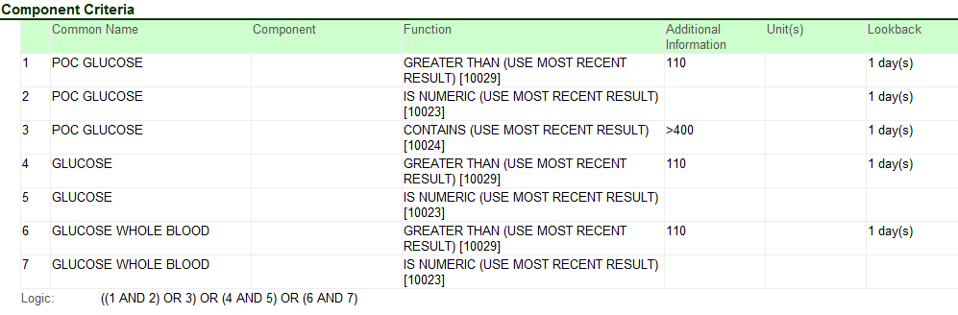

For more information on developing a similar mechanism at your site, contact Amy Fansler ([acf7h@virginia.edu](mailto:acf7h@virginia.edu) or 434-982-6027).