# Stroke CME: SHINE Trial

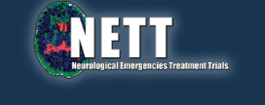



# Learn about the SHINE stroke study and earn 2 HOURS CME Credit

**Stroke Hyperglycemia Insulin Network Effort**

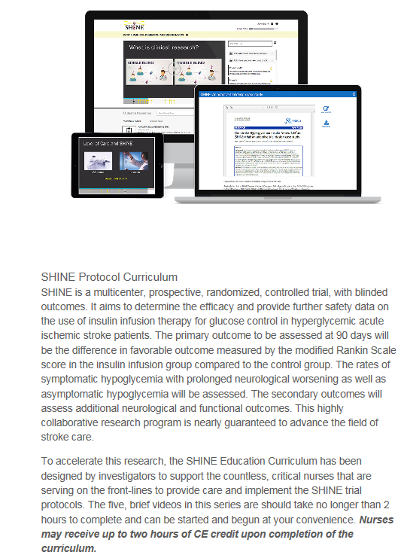

* Go to nett.umich.edu
* Click on SHINE tile
* Click on Nurse Education and Tools
* Select the Clinician Training Webinar
* The link will take you to ArcheMedX where you can register and complete the modules for stroke CME credit



**Have Questions??**

University of Virginia CME Contact: Elizabeth Patterson [EJK6W@hscmail.mcc.virginia.edu](mailto:EJK6W@hscmail.mcc.virginia.edu)

Study Coordinator—Sonya Gunter [SAG7BF@virginia.edu](mailto:WEP2C@virginia.edu)

Study Director—Heather Haughey [HMH8F@virginia.edu](mailto:HMH8F@virginia.edu)

Study Investigator—Karen Johnston [KJ4V@virginia.edu](mailto:KJ4V@virginia.edu)