BPA for Shine Trial:
The BPA looks to identify potential patients that are 18 years or older who are seen in the Emergency Department. In addition, the patient must have a glucose level > 110 and either a specified diagnosis or ED event.
Created the following records for this recruitment BPA:
- EMP 450 (In Basket class)
- EOW 30 (Message type)
- HIP (registry set up paging and/or email)
- HIS (message type definition-Research folder name)
- LGL (Base and criteria)
  - Dx criteria
  - Glucose level criteria
  - ED timeline event criteria (inclusion rule)

The EMP 450 and EOW 30 are created using set nomenclature.

HIP:
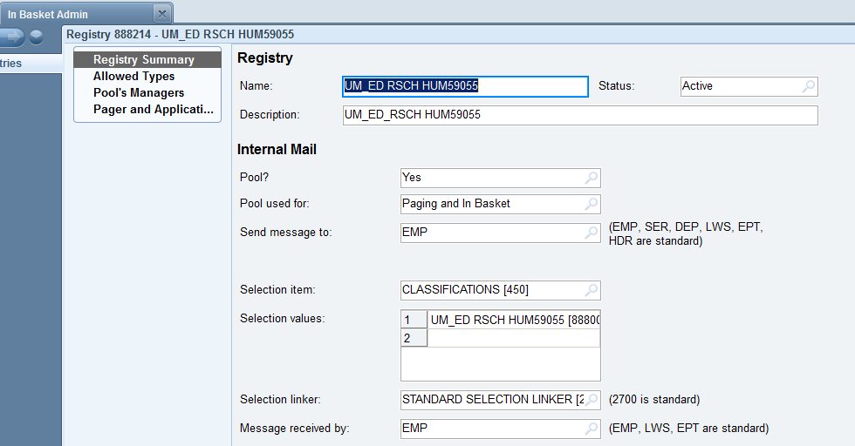
Set up for paging and In Basket. On our system paging and email are done in the same way so that is how I am able to send emails to the study team.
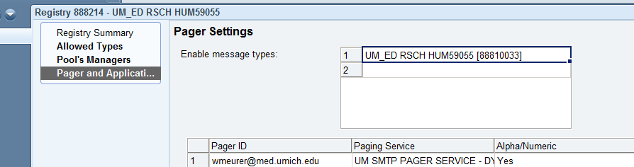
Set up for email or pager can be entered here.

HIS:
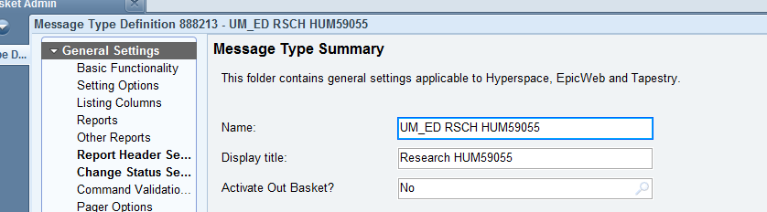
We create separate In Basket folders for Research recruitment BPAs and give the folder the name of “Research and study number”.

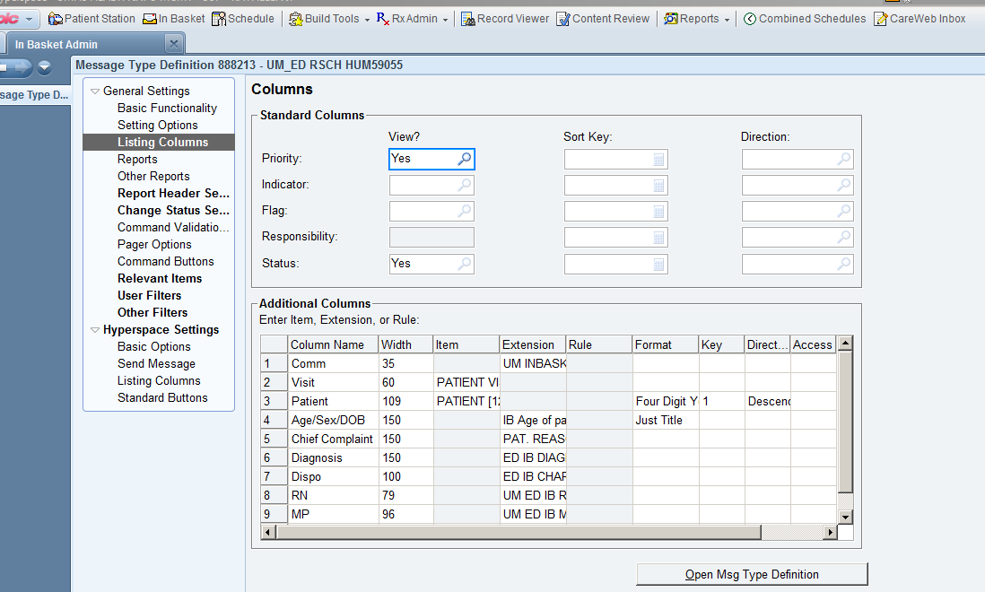
I have set columns that I use for the IB message. Also, I do not allow the pool to take responsibility for the message. I use the comment feature if study team needs to share the IB folder.
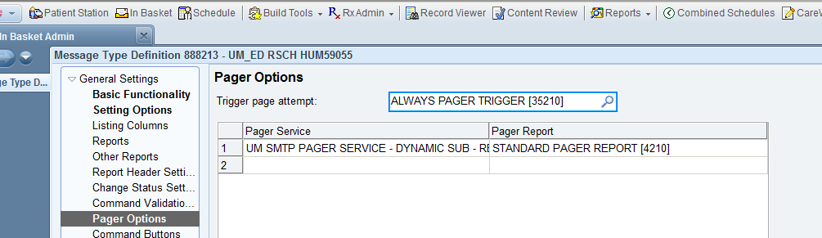
Paging set up.

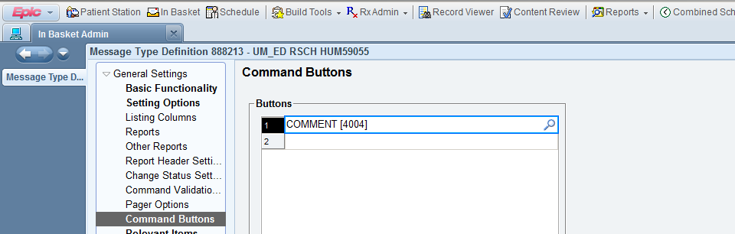
Comment set up.

LGL:
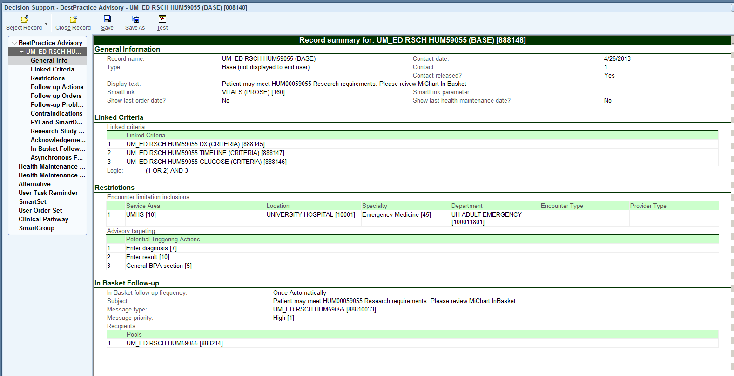
Base record summary. Used 3 criteria.
The Dx criteria had all ICD-9 codes as follows:
- 434.Xxyy
- 433.Xxyy
- 435.Xxyy
The XX represents any number combination. The yy represents any letter combination.
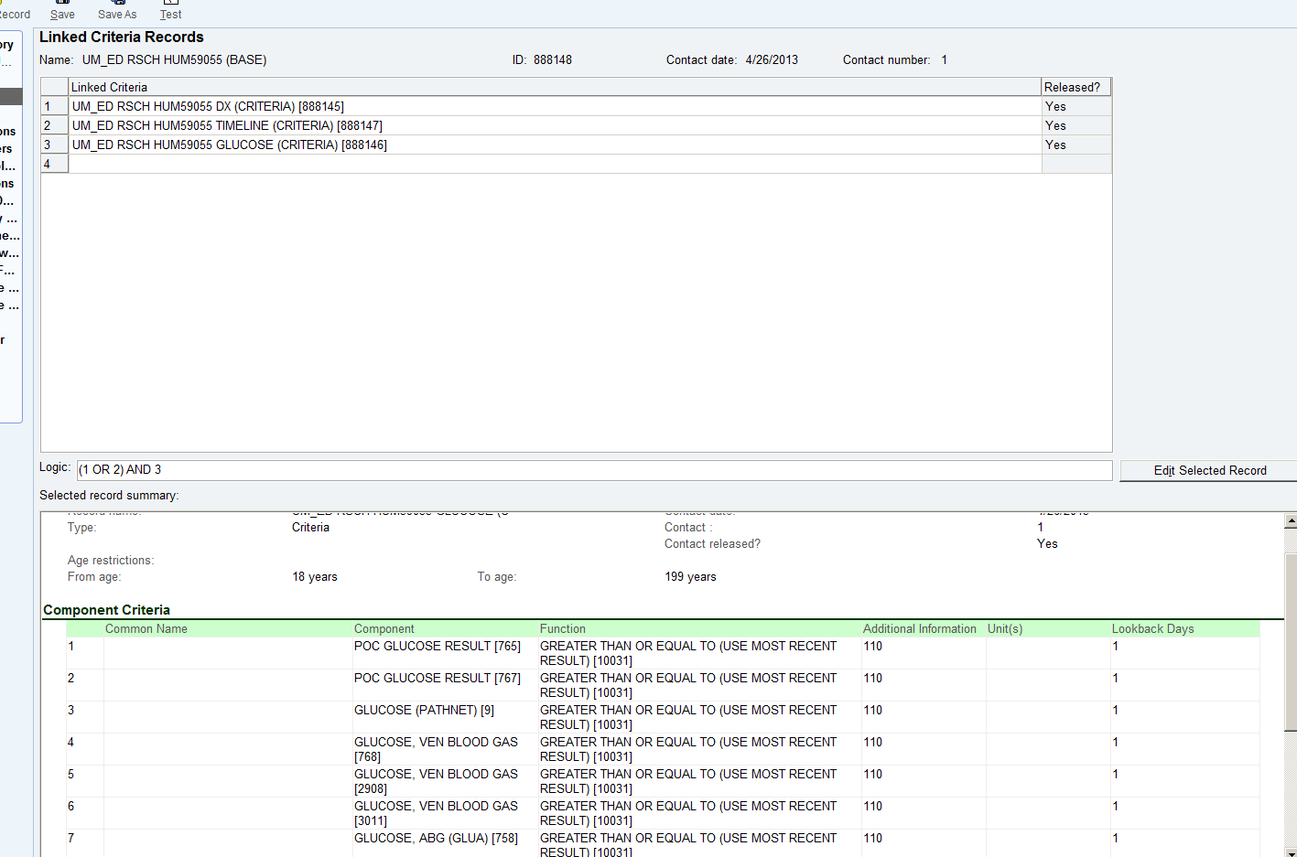
The various glucose components were configured in the component criteria. Value needed to be 110 or greater and we allowed a look back of 1 day.

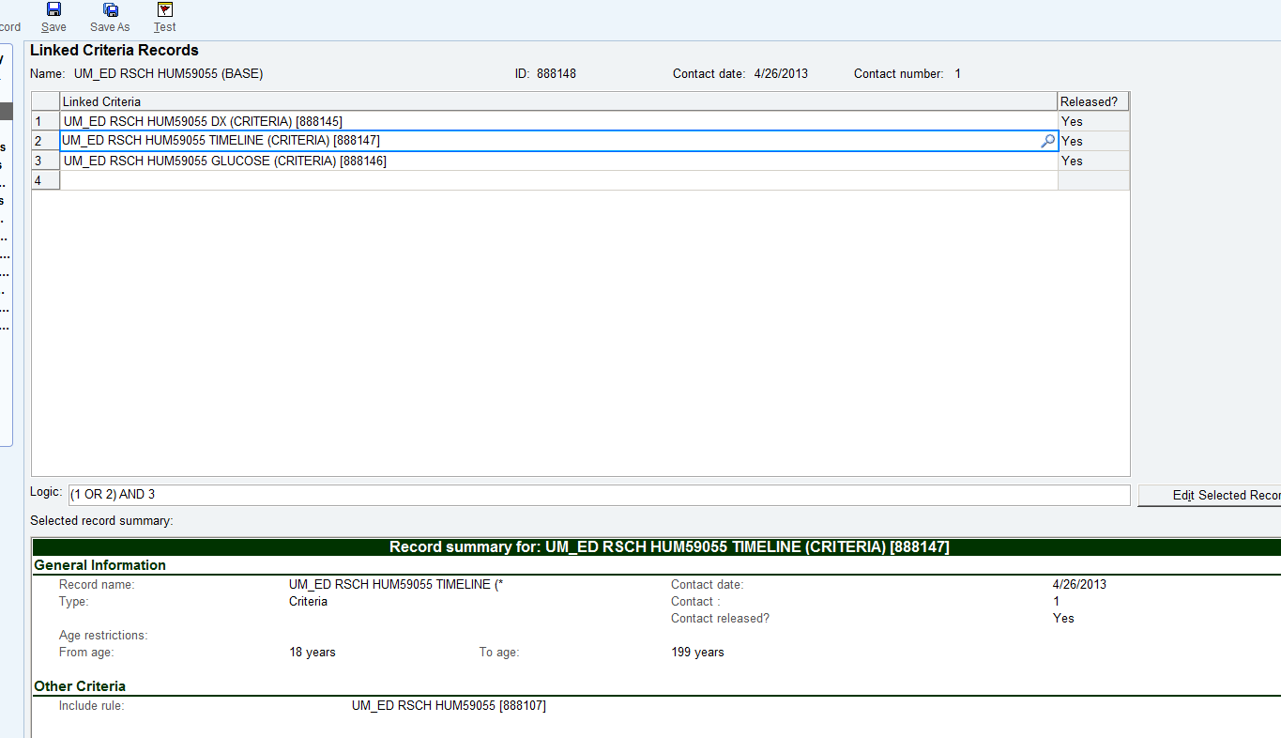
The timeline criteria were sent up as an inclusion rule.
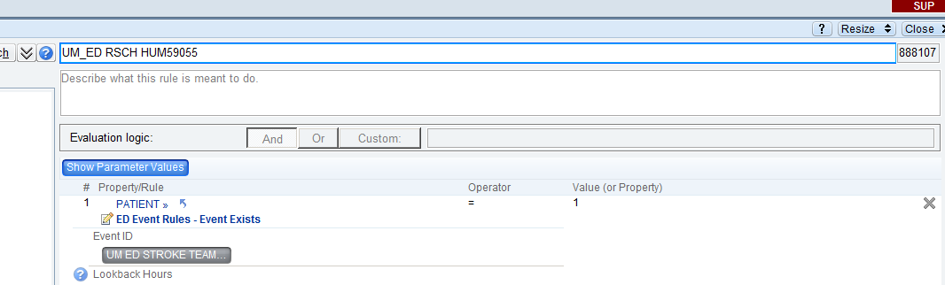
The rule looked for the specified ED Event to exist.

