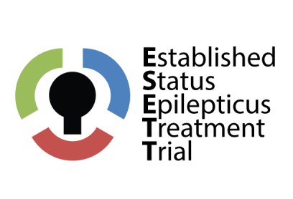
[Date]

[Physician Name]
[Physician Address
_______________]

RE: Announcing an exciting new clinical trial for established Status Epilepticus

Dear Dr. [Physician Name],

We are pleased to notify physicians <insert hospital, city, etc> of an exciting new clinical trial being conducted in your area. Physicians at <insert Enrollment hospital or institution> are participating in a NIH-funded, multi-center center clinical trial called The Established Status Epilepticus Treatment Trial (ESETT). This study is designed to compare the effectiveness of three medications (fos-phenytoin, levetiracetam, and valproic acid) in patients with status epilepticus who have failed benzodiazepines.

To be eligible for enrollment, patients must present at one of our participating hospital Emergency Departments (ED) and meet the following general enrollment criteria:
- Age > 2 years
- Witnessed clinically apparent seizure in the ED
- Received at least an adequate dose of benzodiazepines for generalized, tonic-clonic convulsions within 5-30 minutes prior to enrollment
If eligible, patients will be randomly assigned to one of the three study treatment arms. Because established status epilepticus requires immediate treatment, it will not be possible to obtain informed consent from patients before they are enrolled. Eligible patients at participating EDs will be automatically enrolled into this trial under the U.S. Food and Drug Administration’s exception from informed consent (EFIC) requirements for emergency research (21 CFR 50.24). These special rules allow research studies in certain emergency situations to be conducted without consent. EFIC can only be used when the person’s life is at risk, the best treatment is not known, the study might help the person, and it is not possible to obtain informed consent from the patient or a legally authorized representative.

Everyone in the study will be given standard care in addition to the study treatment (a 10-minute infusion of fos-phenytoin, levetiracetam, or valproic acid). Study patients will be followed closely by study personnel through 30 days or discharge from the hospital, whichever comes first.

As you may know, status epilepticus is associated with significant morbidity, including cognitive defects and neurological injury, and a mortality rate estimated at 17%. It is exciting to think that this study may help physicians treat status epilepticus in the future and improve the care of patients with status epilepticus.

If you would like to read more about this study, please visit the national website at www.esett.org, or contact our local study team at xxx-xxx-xxxx.

Sincerely,

<Site PI Name>
<Site PI study role>
<Enrollment site>

