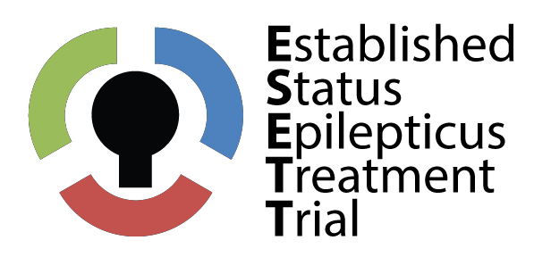

ESETT, Established Status Epilepticus Treatment Trial.
UCSF Community Consultation and Public Disclosure Plan
- Public Disclosure-Newspaper Ads placed in:

- El Tecolote San Francisco based Spanish Language Daily Newspaper.
- International Daily News, a daily Chinese language newspaper in San Francisco
- San Francisco Chronicle, San Francisco’s most widely distributed daily English language newspaper.
- SF Weekly, a weekly free newspaper
- Russian Life Daily Newspaper

- Public Disclosure-On line articles.

- The Northern California Epilepsy Foundation Website at http://www.epilepsynorcal.org/ and electronic newsletter
- UCSF Brain and Spinal Injury Center (BASIC) website at http://www.brainandspinalinjury.org/
- UCSF Today-the UCSF website homepage at http://www.ucsf.edu/

- Public Disclosure-Flyers distributed at

- Flyers to patients and caregivers at UCSF and CPMC Pediatric and adult epilepsy clinics.
- Project Homeless Connect, next is March 11th

- Public Disclosure Radio Stations

- Public Service announcement on Radio Univision
- PSA in Cantonese and Mandarin on radio station KUSF FM Radio.

- Community Consultations-Group presentations.

- FATE (Families/caregivers of Adolescents/children Thriving with Epilepsy) Support Group meeting. (UCSF).
- Bayview Community meeting, a community meeting in the Bayview/Hunter’s Point neighborhood of SF.
- Brainstorm, a TBI support group
- Epilepsy Foundation of Northern California, epilepsy support group members.
- Salvation Army Adult Rehabilitation Services
- Harbor Light Center at 503-3003 (chemical dependency tx rehab for adults, men and women in SF)
- SF General Hospital TBI Clinic/TBI support group
- San Francisco Motorcycle Club
- University of San Francisco Annual Health Fair

